#### **INTRODUCTION**

The displacement crisis of the Rohingya people has emerged as one of the most pressing humanitarian challenges of the 21st century. With nearly 1,000,000 Rohingya refugees (United Nations High Commissioner for Refugees, n.d.) currently residing in makeshift camps in Bangladesh, there is an urgent need for innovative solutions that not only provide basic accommodation but also promote productivity and self-sufficiency (Milton et al., 2017). This paper explores the conceptual development of an intelligent accommodation system for Rohingya refugees, integrating sustainable living conditions with opportunities for economic and social productivity while ensuring security by utilizing the capabilities of artificial intelligence (AI).

#### **Problem Background**

The Rohingya, an ethnic minority from Myanmar, have faced decades of systemic persecution, leading to mass displacement. The influx of refugees into Bangladesh, particularly in the Cox’s Bazar region, has placed immense pressure on resources and infrastructure. Traditional refugee camps often focus solely on providing immediate relief, such as food and shelter, without addressing long-term sustainability and the potential for refugees to contribute economically and socially (Bhatia et al., 2018).

To illustrate the gravity of the situation, consider the story of Tasmin, a 51-year-old Rohingya woman who fled Myanmar’s Rakhine State after horrific violence was waged against her ethnic minority group in late 2017. Tasmin and her five children escaped to the forests behind their home, hiking for eleven days before reaching the Naf River, which marks the border between Myanmar and Bangladesh. Tasmin’s family was resettled in Kutupalong, where they joined nearly one million other Rohingya refugees. Tasmin's story reflects the extreme trauma and severe hardships that all Rohingya refugees endure in these overcrowded camps, where they face dire living conditions, including inadequate shelter, food shortages, and a lack of basic sanitation and healthcare (Relief International, 2019).

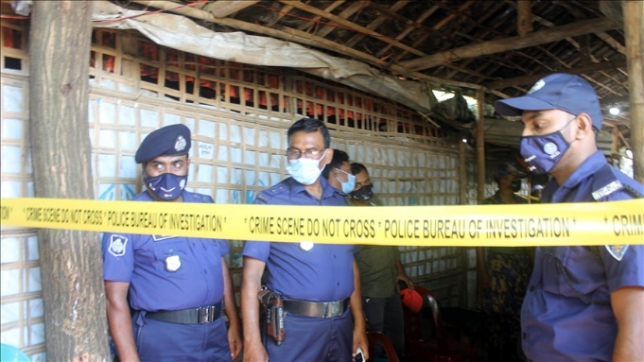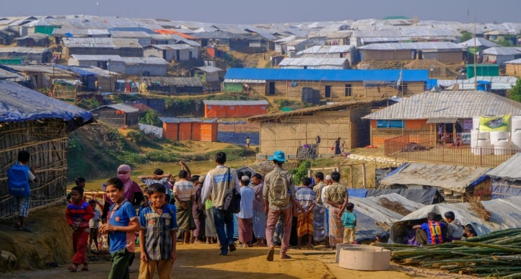

Figure 1: Kutupalong Refugee Camp (Humanity & Inclusion Canada, n.d.)

Figure 2 - Bangladesh police stand guard in front of the madrassa at the Balukhali refugee camp where six Rohingya were killed in an attack on Oct. 22, in the Ukhia sub-district of Cox’s Bazar, Oct. 26, 2021. (Benar News, 2021)

Adding to these challenges, an alarming rise in crimes within the camps, including murders and

drug-related offenses, has been reported. These crimes are often linked to the activities of armed groups such as the Arakan Rohingya Salvation Army (ARSA) and the Arakan Solidarity Organization (RSO; The Daily Star, 2023). Moreover, the issue of Rohingya refugees obtaining fake Bangladeshi identification documents further complicates the security dynamics within the camps, creating an environment of instability and fear (Dhaka Tribune, 2023). The rise in crimes can be attributed to several factors, including the lack of economic opportunities and the pervasive sense of hopelessness among refugees. Many jobless youths, facing severe economic deprivation, become involved in criminal activities as a means of survival. Additionally, competition among armed groups for control over illegal activities such as drug trafficking and extortion fuels further violence and instability within the camps (Dhaka Tribune, 2023).

The problems that this research aims to address can be broadly summarized into two main issues:

* **Inadequate living conditions and lack of long-term sustainability**: Current refugee accommodations hinder the economic self-sufficiency and social productivity of Rohingya refugees.
* **Escalating security problems within camps**: Issues such as crime and the misuse of identification documents further destabilize the already precarious environment.

This paper addresses the critical need to rethink refugee accommodation from a perspective that includes productivity, self-reliance, and enhanced security.

#### **Related Studies**

The conditions within Rohingya refugee camps have been the subject of various academic studies, each shedding light on different aspects of the refugee crisis. For instance, Bhatia et al. (2018) provide an in-depth analysis of the living conditions in the camps, emphasizing the inadequacy of basic facilities and the lack of economic opportunities. Their study highlights the dire need for improved infrastructure and sustainable living conditions but falls short of proposing actionable solutions for long-term self-sufficiency and economic integration.

Similarly, Milton et al. (2017) focus on the health challenges faced by the Rohingya refugees due to overcrowding and poor sanitation. While this study offers valuable insights into the public health crises within the camps, it does not explore the broader socio-economic factors contributing to these conditions or how technology could mitigate them.

The research by Ahmed et al. (2019) further explores the status of Rohingya refugees in Bangladesh, highlighting the extreme hardships they endure, including inadequate shelter and limited access to education and healthcare. However, like previous studies, it does not address the potential for integrating technological solutions to improve the overall quality of life and security within the camps.

Hossain et al. (2020) delve into the security issues within the camps, particularly focusing on the rise in crimes and the involvement of armed groups. Their research underscores the complex security dynamics in the camps but does not consider how AI and other advanced technologies could be leveraged to enhance security and stabilize the environment.

Despite the valuable contributions of these studies, there is a noticeable gap in the literature regarding integrated solutions that combine sustainable living conditions with productivity-enhancing features and advanced technologies like AI. None of the existing research comprehensively addresses the need for a holistic accommodation system that not only meets the basic needs of refugees but also empowers them to achieve economic self-sufficiency and social productivity while ensuring their security.

This research aims to fill that gap by proposing an intelligent accommodation system that incorporates AI to optimize resource allocation, enhance security, and support economic integration within the refugee camps. By addressing these gaps, this study will contribute significantly to the field of humanitarian aid and refugee studies, offering a model that can be adapted and implemented in similar contexts globally.

#### **Research Objectives**

This research proposes an intelligent accommodation system for Rohingya refugees that integrates sustainable living conditions, productivity opportunities, and enhanced security. The goal is to create a framework addressing both immediate needs (shelter, sanitation, healthcare) and long-term sustainability (environmental practices, resource availability). Economic activities will be incorporated, promoting refugee self-reliance and transforming camps into productive communities. To address security issues like crime and armed group influence, the framework will leverage AI to enhance security measures and optimize resource allocation. Though the study does not aim to implement the system, it will offer a conceptual model answering: " **How to develop an intelligent accommodation system for Rohingya refugees that facilitates productivity, ensures security, and leverages AI?**"

#### **Research Contributions**

This study contributes to humanitarian aid, refugee studies, and AI-driven social innovation by presenting a framework for intelligent accommodation systems tailored to Rohingya refugees. It provides insights for policymakers and organizations on using AI to create sustainable, secure environments while enhancing refugee productivity. By integrating AI in resource management and security, the research offers solutions that reduce refugee dependency, promote self-sufficiency, and alleviate the socio-economic burden on host countries.

#### **METHODOLOGY**

The methodology of this study is based on a systematic literature review (SLR) approach, designed to comprehensively evaluate existing research and literature relevant to the development of intelligent accommodation systems for Rohingya refugees. This approach ensures a thorough and unbiased collection of data that contributes to forming a robust framework for addressing the research problem. The SLR method follows the guidelines set by Kitchenham et al. (2010) and Petersen et al. (2008), which emphasize the importance of systematic data collection and analysis.

#### 3.1 Search Strategy

The search strategy employed in this study was designed to locate the most relevant academic and scholarly sources across multiple databases. The selected databases include IEEE Xplore, SpringerLink, ScienceDirect, ACM Digital Library, IGI Global, Google Scholar, and Wiley Online Library. These databases offer extensive coverage of technological and humanitarian literature, essential for the interdisciplinary nature of this research.

#### 3.1.1 Keywords and Boolean Logic

A combination of carefully selected keywords was utilized to refine and target the search results. Boolean operators were applied to manage and expand the search results effectively. The following keywords and Boolean logic were used:

* "Rohingya refugees" AND "accommodation system" AND "artificial intelligence"
* "refugee productivity" OR "sustainable refugee camps"
* "AI in refugee security" AND "systematic review"

This strategic combination of search terms helped ensure the search was both comprehensive and focused on relevant studies.

#### 3.1.2 Forward and Backward Search Techniques

In addition to the primary search using databases, both forward and backward citation search techniques were employed. This included reviewing the references cited in key articles (backward search) as well as identifying more recent publications that cited these articles (forward search). This approach ensured that all relevant literature, including the most recent studies, was considered in the review process. This comprehensive search strategy minimizes the risk of omitting any critical studies or emerging research.

#### 3.2 Inclusion and Exclusion Criteria

To ensure the relevance and quality of the reviewed literature, specific inclusion and exclusion criteria were applied throughout the selection process.

### *3.2.1 Inclusion Criteria*

* Peer-reviewed journal articles and conference papers.
* Studies focusing on refugee accommodation, AI applications in humanitarian settings, and security.
* Publications in English.
* Articles published between 2000 and 2024.
* Studies that included abstract or title discussions relevant to refugee accommodation systems or AI in humanitarian settings.

#### 3.2.2 Exclusion Criteria

* Non-peer-reviewed articles, such as opinion pieces or editorials.
* Studies not explicitly addressing AI or accommodation systems in refugee contexts.
* Articles where only titles were relevant but lacked substance in abstracts or full texts.
* Publications without sufficient detail or methodological rigor.

#### 3.3 Selection Process

The selection process was designed to systematically screen studies based on their relevance to the research question

#### 3.3.1 Initial Screening

An initial search of the academic databases yielded 87 articles after applying the defined keywords. Titles and abstracts of these papers were reviewed to determine their relevance to the research question. This initial screening was based on whether the articles mentioned AI, refugee accommodation, and security systems, among other factors.

#### 3.3.2 Secondary Filtering

Following the initial screening, the inclusion and exclusion criteria were applied to refine the list. This stage involved filtering out studies that lacked peer-reviewed rigor or relevance to AI-driven accommodation systems for Rohingya refugees. After this stage, 30 articles remained for further review.

#### 3.3.3 Final Selection

A detailed review was conducted on the remaining 30 articles, which led to a final selection of 13 studies. These were chosen based on their direct relevance to the research objectives, as well as their methodological rigor. Both free full-text articles and those available only through abstracts were considered in this review, with abstracts used to extract data when full texts were not accessible.

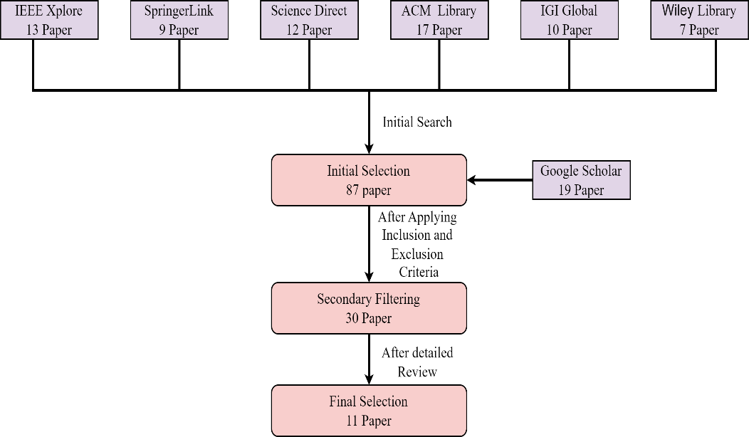

**Figure 3** Literature Search and Article Selection for Systematic Review

#### 3.4 Data Extraction and Synthesis

Data extraction was performed with a standardized approach to ensure consistency. For freely available articles, detailed information was gathered from all sections including the abstract, methodology, results, and discussion. For articles where only abstracts were accessible, data extraction focused on the abstracts. This method facilitated a broad review of available literature while acknowledging the limitations imposed by paywalls.

#### 3.4.1 Data Extraction Process

A standardized data extraction form was used to methodically collect information from each study. For fully accessible articles, comprehensive data were extracted across all sections: abstract, introduction, methodology, results, and conclusions. This thorough examination was aimed at obtaining a holistic understanding of each study's contributions. For articles limited to abstracts, the extraction focused on gleaning the most significant points that related to the research objectives of developing an intelligent accommodation system for Rohingya refugees.

#### 3.4.2 Thematic Synthesis

The information extracted was then analyzed thematically, grouping studies into relevant themes such as "AI applications in refugee settings," "security enhancement through technology," and "initiatives for economic productivity." This synthesis helped identify prevalent trends, highlight significant gaps, and pinpoint emerging opportunities within the research area.

#### 3.4.3 Quality Assessment

Quality assessment was performed on the selected studies based on criteria including citation count, publication in high-impact journals, and the rigor of the methodology employed. This rigorous assessment ensured that only high-quality studies were included in the synthesis, enhancing the credibility and impact of the research findings.

results and analysis

***a. Research Data***

|  |
| --- |
|  |
| **Alam, F. R., Munir, M. B., Ishrak, S., Hussain, S., Reza, F., Khan, N. S., Tumpa, S. N. & Karim, M. M. (2018). *An automated cloud-based digitized management system for Rohingya refugee camp in Bangladesh.* 2018 International Conference on Electrical, Computer, and Communication Engineering (ECCE), Chonburi, Thailand.** |
| The study outlines a cloud-based management system aimed at improving the organization and efficiency of refugee accommodation through a centralized database for tracking resources, services, and refugee information. Key findings highlight the importance of unique and biometric identification to enhance security, trustworthiness, and resource allocation, fostering a more productive environment for both refugees and management. |
| **Wardeh, M., & Marques, R. C. (2021). Sustainability in refugee camps: A systematic review and meta-analysis. *Sustainability*, *13*(14), 7686** |
| The systematic review emphasizes the need for sustainable planning in refugee camps, integrating local knowledge and technology to create secure, productive environments. Key sectors for improvement include health, education, and economic growth, with long-term policies essential for enhancing refugees' quality of life, particularly for the Rohingya community. |
| **Dala, A., Darweesh, A., Misselwitz, P., & Steigemann A. (2018). Planning the Ideal Refugee Camp A Critical Interrogation of Recent Planning Innovations in Jordan and Germany. *Urban Planning, 3*(4), 64** |
| The paper emphasizes the need for improved shelter design in refugee camps by integrating urban planning principles to enhance productivity and security. It critiques bureaucratic systems and advocates for more flexible, self-determined living arrangements to empower refugees. While innovative designs in Berlin and Jordan foster community, they often lack genuine agency and control for residents, which is vital for a productive and secure environment for Rohingya refugees. |
| **Sabie, D., & Ahmed, S. I. (2019). *Moving into a technology land: exploring the challenges for the refugees in Canada in accessing its computerized infrastructures.* COMPASS '19: Proceedings of the 2nd ACM SIGCAS Conference on Computing and Sustainable Societies, Accra, Ghana.** |
| The paper highlights challenges refugees face in accessing technology, impacting their productivity and security. It stresses the need for inclusive technology design that accounts for low literacy and cultural constraints, especially for women. Addressing these issues through an intelligent accommodation system could improve resource access, digital skills, and safety, aiding Rohingya refugees' integration and productivity. |
| **Marji, N., & Kohout, M. (2022). *From Temporary Shelter to Permanent Dwelling: Optimizing the Spatial Organization of Refugee Camps in Jordan through Artificial Intelligence.* Academic Mindtrek 2022: 25th International Academic Mindtrek conference, Tampere, Finland.** |
| The paper emphasizes the need for adaptive planning in refugee camps, using artificial intelligence to improve spatial organization. It suggests that intelligent accommodation systems can enhance living conditions, self-determination, and productivity while ensuring security through better resource management. Involving refugees in the design process leads to more effective and sustainable accommodation solutions. |
| **Hossain, S. M., Zhang, H., Hossain, M. S., & Yun, L. (2020). Rohingya Refugee Crisis: Security Concerns for Bangladesh. *South Asian Journal of Social Studies and Economics 8*(2), 24-34.** |
| The paper underscores the need for a structured approach to the Rohingya refugee crisis, focusing on security and the safe return of refugees. It highlights vulnerabilities due to irregular status and limited resources, suggesting that an intelligent accommodation system could enhance productivity and address security concerns through effective management. The study also emphasizes the importance of international cooperation and humanitarian support for creating a sustainable environment for refugees. |
| **Easen, O., & Binatli, A. O. (2017). The Impact of Syrian Refugees on the Turkish Economy: Regional Labour Market Effects. *Social Sciences, 6*(4), 129** |
| The paper highlights that the influx of refugees, like Syrians in Turkey, significantly affects local labor markets, often increasing unemployment and informal employment. It emphasizes the need for effective integration strategies to enhance productivity and security. These insights can guide the development of an intelligent accommodation system for Rohingya refugees, focusing on labor market integration and secure living conditions to foster community stability. |
| **İncetahtacı, N. (2024). The role of university-NGO cooperation in increasing the entrepreneurial skills of youth: An evaluation specific to refugee youth. *International Journal of Education, 39*(2), 507-523.** |
| The study highlights that improving refugee youth productivity requires addressing challenges like limited resources, legal complexities, and cultural barriers. It emphasizes the importance of university-NGO collaborations in providing training and mentorship to empower refugees and enhance their economic contributions. Fostering social cohesion and cultural understanding is also crucial for ensuring productivity and security in refugee communities. |
| **Georgious, T., Baillie, L., & Shah, R. (2023). Investigating Technology Concepts to Support Rohingya Refugees in Malaysia. doi:10.48550/arXiv.2304.01617** |
| The findings highlight that the system must ensure secure living conditions with features like surveillance and emergency communication tools. Additionally, integrating information hubs within the accommodation can improve refugees' access to vital services, enhancing productivity and community integration. |
| **Filipski, M. J., Rosenbach, G., Tiburcio, E., Dorosh, P., & Hoddinott, J. (2020). Refugees Who Mean Business Economic Activities in and Around Rohingya Settlements in Bangladesh. *Journal of Refugee Studies, 34*(1), 1202-1242.** |
| The study reveals that Rohingya refugees participate in trade and services but face challenges such as lower wages and limited resources compared to locals. It suggests that an intelligent accommodation system should improve market access, provide security measures, and facilitate skill development to enhance productivity and ensure safety for refugees. |
| **Wolf, S. (2014). The Rohingyas crisis: a security perspective from Bangladesh. *APSA Comment, 11*(21), 1-11.** |
| The paper finds that the Rohingya crisis is seen as a non-traditional security threat in Bangladesh, contributing to religious fundamentalism and challenging governance and civil service integrity. Addressing involvement in transnational crime and distinguishing between moderate and radical elements is crucial for regional security and stability. |

**b.Proposed Solution**

Proposed Solution for an Intelligent Accommodation System

1.Centralized Data Management and Identification:

* Ensure the mention of AI-driven centralized databases is strongly aligned with refugee-specific security needs, such as biometric systems that were emphasized in the findings by Alam et al. (2018). You could also highlight that this data management would ensure better coordination among humanitarian organizations.

2. Improved Refugee Living Conditions:

* Sustainability: Emphasize the importance of sustainable technologies, as mentioned by Wardeh & Marques (2021). For example, use AI to monitor the energy use and waste management to promote eco-friendly living conditions. Incorporating participatory planning could also address the issues of inclusivity, as highlighted in the study on urban planning principles by Dala et al. (2018).

3. Economic Empowerment:

* Align economic empowerment more closely with **skill development and market access**, as discussed by İncetahtacı (2024) and Filipski et al. (2020). You can mention creating virtual training hubs and promoting digital marketplaces for refugee entrepreneurs, which will also facilitate social cohesion and allow for economic integration with the local host communities.

4. Enhanced Security Measures:

* In addition to AI-driven surveillance, focus on **community-based policing** or collaboration with local authorities to increase trust and enhance security, especially considering the security concerns raised by Hossain et al. (2020). Also, emphasize secure digital systems to reduce the misuse of identification documents.

5. Community Integration and Social Cohesion:

* Incorporate **education and mentorship programs** as a core component to bridge cultural gaps between refugees and host communities. Citing the paper by İncetahtacı (2024), suggest collaborative efforts between universities and NGOs that could help foster entrepreneurial skills and create long-lasting community bonds.

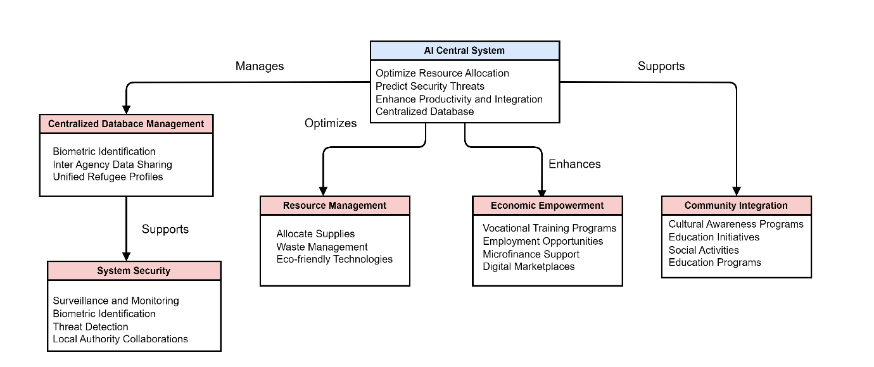

Figure 4 – Diagram of Proposed Ai driven accommodation system for Rohingya refugees